Bug_01:
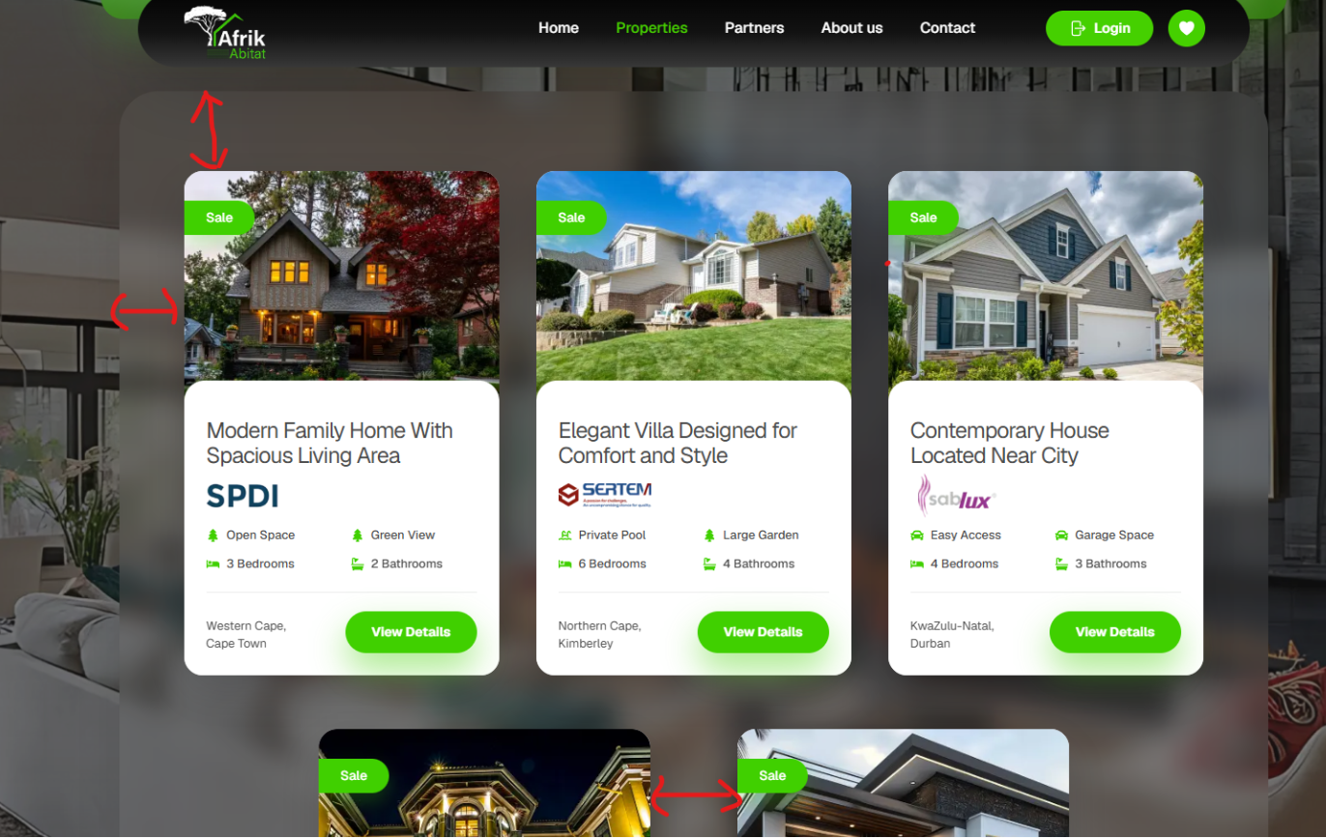
Space issue and background blur should be light in color
Bug_02:
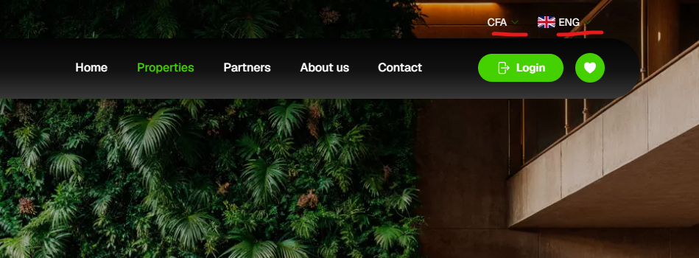
Dropdown option not visible

Bug_03:

Green shade missing

